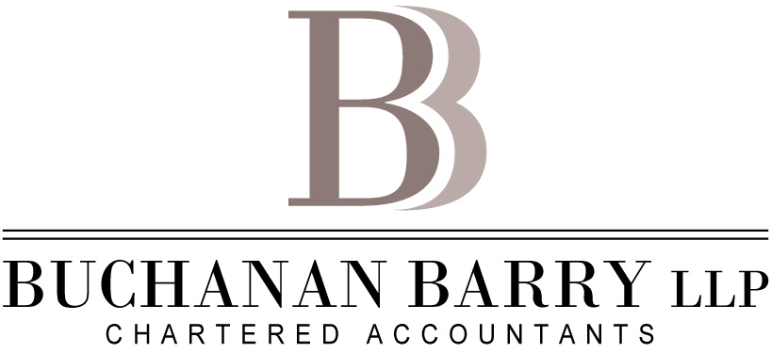

Senior Staff Accountant
Buchanan Barry LLP – Calgary, Alberta

Have you reached a glass ceiling? Are you looking for a better work life balance? Are you looking for a mid-size down-to-earth public accounting firm to grow with? Buchanan Barry LLP might be the fit you are looking for!

In business for more than 50 years, Buchanan Barry LLP provides its clients with outstanding service and its staff with an environment that promotes work-life balance. We encourage active living and strive to create an atmosphere that supports health and productivity.

We are looking for Senior Staff Accountants to join our team! The core skills and responsibilities of this position are:

- Preparation of financial statements and tax returns in accordance with Firm standards for clients in a variety of businesses and non-profit enterprises;
- Conducting audits on small to medium sized organizations in a variety of industries;
- Auditing financial statements of business clients as a team member or audit senior;
- Effective communication with our clients, government agencies and with our partners and staff;
- Keeping partners and other team members informed, on an ongoing basis, of progress and significant issues; and
- Providing advice and training to other staff members.
Requirements:
- CPA Designation or written CFE exam waiting for results;
- Strong analytical and problem-solving skills;
- Solid verbal and written communication skills;
- Ability to prioritize and manage multiple tasks;
- Strong work ethic, excellent communication and organizational skills; and
- Proficiency with Microsoft Office programs including Microsoft Word and Excel and Simply Accounting. Experience with Caseware and Profile computer programs will be considered an asset.

If this position seems like an ideal opportunity for you, and you would like to join our team, please submit your resume and cover letter in confidence to: hr@buchananbarry.ca

*Please note that third party resumes will not be considered and only those selected for an interview will be contacted.

